A PROJECT REPORT

ON

(Scope Of Digital Apps in Gwalior )

AT

(IDEA CELLULAR GWALIOR)

Submitted to

Jiwaji University

Gwalior

For the partial fulfillment of the award of Master of Business Administration/ Bachelor of Business Administration / Bachelor of commerce

(2018)

Submitted BY

(Sonal Sharma)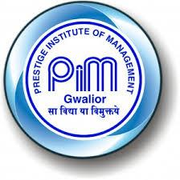

PRESTIGE INSTITUTE OF MANAGEMENT, GWALIOR (M.P.)

Declaration by the Candidate

I hereby declare that the training report entitled, “**Scope of Digital Idea In gwalior**.” submitted by me to Prestige Institute of Management, Gwalior in fulfillment of the requirement for the award of masters of Business Administration is a record of my original work carried out by me under the guidance of **Prof .Chanda Gulati**. I, further declare that the work reported in this report has not been submitted, and will not be submitted, either in part or in full, for the award of any other degree or diploma of this University or to any other institute or university.

Date:

Place:

Signature of the candidate

(Sonal Sharma)

CERTIFICATE FROM FACULTY GUIDE

This is to certify that Mr./ MS. Student of **Sonal Sharma** program has completed his/her summer training of **Idea Cellular** Weeks from **25/07/17** **to 07/09/17** and prepared this report entitled **Prof. Chanda Gulati** under my guidance. His/ her performance during the training was excellent.

Date:

(Signature of Faculty Guide…………………………….)

Name of Faculty Guide

Prof. Chanda Gulati

**Acknowledgement**

I undertook this training in the partial fulfillment of my **M.B.A.** curriculum. I am glad that I got wonderful opportunity to do my Project report at Idea Cellular HR is one of the key parts and the backbone of any company. Without human resources management no organization can survive.

I sincerely acknowledge my gratitude towards the faculty guide **Assistance** **Professor. Chanda Gulati** who gave me the thorough understanding of different concepts.

I am extremely grateful to **Ms Nilofer Khan** **(HR. Executive) Mr. Suraj Singh** who was not only supportive and co-operative but in spite of their busy schedule he was ready to help me I am thankful to him for his valuable guidance and support which is of high worth.

**Sonal Sharma**

**MBA 3rd Sem**

**TABLE OF CONTENTS**

**CHAPTER 01:**

* 1. History of the Organization & Objectives of the organization
  2. Organizational Structure

**CHAPTER 02:**

2. 1Financial Performance (Including quantitative aspects) & position, Costing methods and analysis of statements

* 1. Personnel: Recruitment process, Personnel Policies, Training and Development and welfare activities
  2. Productions/ operations: products/ services offered , lay out of the facility, quality control, materials planning & control future plans
  3. Marketing : areas of operations, competititors, market share, advertising & sales promotion

**CHAPTER 03:**

* 1. Strengths and weakness of the organization
  2. Any other special point observed by you

**CHAPTER 04 :**

4.1 Introduction of the concept  
4.2 Application of the Concept in Organization

4.3 Suggestions and Implication

**CHAPTER 05:**

Conclusion

**CHAPTER 1**

## 1.INTRODUCTION

Idea Cellular commonly referred to as simply Idea, and stylised as, Idea is an Indian mobile network operator based in Mumbai, Maharashtra. Idea is a pan-India integrated GSM operator offering 2G, 3G and 4G mobile services. Idea is India’s third largest mobile operator by subscriber base. Idea has 191 million subscribers as of 31 December 2016.

During its inception in 1995, Aditya Birla Group, Tata Group and AT&T Wireless each held one-third equity in the company. Following AT&T Wireless' merger with Cingular Wireless in 2004, Cingular decided to sell its 32.9% stake in Idea. This stake was bought by the remaining two stakeholders equally.Tata forayed into the cellular market with its own subsidiary, Tata Indicom, a CDMA-based mobile provider and in April 2006, Aditya Birla Group announced the acquisition of the 48.18% stake held by Tata Group at INR 40.51 a share amounting to INR 44.06 billion with 15% of the stake acquired by Aditya Birla Nuvo and the remaining by Birla TMT holdings Private Ltd. both AV Birla family owned companies. Malaysia based [Axiata](https://en.wikipedia.org/wiki/Axiata_Group_Berhad) bought a 19.96% stake in the company in 2009

# **1.1 HISTORY OF IDEA CELLULAR**.

Idea Cellular is an Aditya Birla Group Company, India's first truly multinational corporation. Idea is a pan-India integrated GSM operator offering 2G, 3G and 4G services, and has its own NLD and ILD operations, and ISP license. Idea is one of the top three mobile operators in India, with an annual revenue in excess of USD 5 billion and a revenue market share of 19%. With nearly 200 million subscribers, Idea ranks sixth in the global rankings of operators in subscriber terms, for single country operations.

In line with the Government vision of Digital India, Idea has accelerated its efforts of building a digital economy. Backed with a pan-India wireless broadband coverage, Idea has forayed into Digital services with the launch of a suite of digital entertainment apps , Idea Music Lounge, Idea Movie Club and Idea Game Spark. With this the company has begun its transformation from a pure play mobile operator to an integrated digital services and solutions provider. Idea will also expand its digital offerings into digital communication, digital payments, cloud Aditya Birla Idea Payments Bank.

 Idea’s pan-India network covers over 400,000 towns and villages across the country. The company is further expanding network infrastructure to make high speed mobile broadband services reach out to over a billion population of the country. Idea executed the fastest 4G roll-out in the country in 2016 - with one broadband site being installed every ten minutes - taking the overall tally of Idea sites to nearly 230,000 and a fibre network of over 1.28 lakh kms. By March 17, Idea 4G services will be expanded to 20 circles covering 94% of its revenue market.

**OBJECTIVES OF ORGANIZATION**

### Integrity

Acting and taking decision in a manner that these are fair, honest, following the highest standards of professionalism and are also perceived to be so. Integrity for us means not only financial and intellectual integrity, but in all other forms as are commonly understood.

### Commitment

On the foundation of Integrity, doing whatever it takes to deliver value to all stakeholders. In the process, taking ownership for own actions and decisions, those of our team and that part of the organisation that we are responsible for.

### Passion

A missionary zeal arising out if emotional engagement with the organisation that makes work joyful and inspires each one to give his or her best. Relentless pursuit of goals and objectives with the highest level of energy and enthusiasm, that is voluntary and spontaneous.

### Seamlessness

Thinking and working together across functional silos, hierarchy, business and geographies. Leveraging the availability diversity to garner synergy benefits and promote oneness through sharing and collaborative efforts.

### Speed

Responding to internal and external customer with a sense of urgency. Continuously seeking to crash timelines and choosing the right rhythm to optimize Organization efficiencies.

## 1.2 HIERACHY ORGANIZATION STRUCTURE

Idea has a clear limited hierarchical Organization Structure. A hierarchical structure clearly defines each employees role within the organization and defines the nature of their relationship with other employees. This type of organizational structure ensures command and control of he whole organization. Idea operated in 22 circle all over india and each circle has a main circle office headed by the circle head. Different departments heads Hr, Sales, Finance Etc. the circle heads report to the CXOs and MD at the Corporate head office in Mumbai.

Idea also has dotted line reporting between different department heads at the circle level and their respective CXOs at the corporate level. The structure emerges form the idea that the organization must perform certain functions in order to carry on it’s operations.

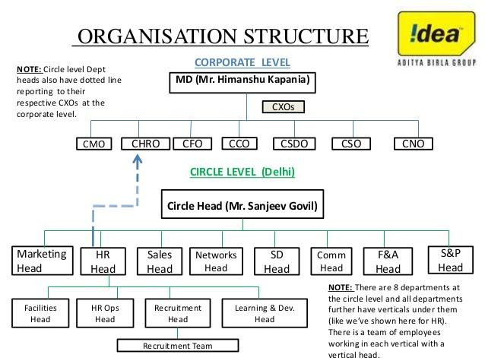

## 1.3 LAUNCH OF DIGITAL IDEA

On January 30, 2017 The Company announced its arrival into the digital world with launch of 3 new exciting Mobile Apps Idea Music Lounge, Idea Movie Club and Idea Game Spark giving birth to a **"Digital Idea"** The new suite of integrated Digital Apps provides one of the best ranges of entertainment content to The Company's 192 Million plus customer base. These Apps deliver world class user experience in domains that are 'telecom adjacencie viz. Music, Movies, Live TV and Gaming.

The Digital Idea movement will not only digitize our existing processes and strengthen them, but will also build the Company's capability for future marking first entry of Idea into internet based economy. Within first 60 days of introduction of digital entertainment applications around 1.5 million customers started to enjoy Idea's digital content services including approximately 5,50,000 customers on Idea Music App, around 2,75,000 customers on Idea Movie Club App and around 5,00,000 customers on Idea Game Spark App. A growing percentage of Idea's existing customers prefer prepaid recharges, postpaid payments and product activations on the Company's digital channels and The Company remains committed to push online adoption even further, in line with our Prime Minister's Digital India vision.

The Company has been constantly driving Digital Enablement by augmenting the capabilities on its Website and simplifying My Idea mobile application. As on March 31, 2017, over 10 Mn Idea subscribers have installed The Idea mobile application for self-care and product purchases. Similarly to keep pace with changing customer expectations and ensuring seamless customer experience at all times, The Company has embarked on Customer Experience Management and advanced analytics journey during the year. This enables delivery of a superior customer experience for mobile broadband and data services and proactive customer care practices through accurate diagnostics leading to higher up-time and an even higher satisfaction for its customers.

## 1.4 4G LAUNCH

The Company now provides 4G services in 19 service areas, with 7 new service areas launched through 1800 MHz spectrum in Gujarat, Uttar Pradesh , Bihar, Rajasthan, West Bengal, Assam and Jammu & Kashmir and 1 service area of Uttar Pradesh launched on 2100 MHz integrating spectrum acquired in

October, 2016. Launch of 4G services in Mumbai Service area is scheduled in Q1 FY18 through 2100 MHz frequency band. In the October, 2016 Spectrum Auction,

The Company won 2*54.6 MHz spectrum block in 1800 frequency band and 20 MHz in 2100 MHz frequency band including 4G LTE compatible contiguous blocks of 5 MHz in 9 service areas and 3G spectrum in 2 service areas. Further in October 2016 auctions, The Company won additional capacity of 30 MHz in three service areas in 2300 MHz band and 170 MHz in 16 service areas in 2500 MHz band. As at end of March 2017, the Company provides 4G coverage to 272 million Indian population with 40,852 sites across 23,000 towns and villages. Post launch of 4G services in 9 new service areas and 3G in 2 new service areas the broadband service offerings 3G / 4G of the Company now covers 21 service areas on its own broadband spectrum, 96.5% of Idea revenue and ~93.5% of Industry revenue As per Q3 TRAI reported revenue and more than 500 million Indians.

L

## 1.5 PAPERLESS E-KYC ACTIVATIONS

Taking the digital dream of our Honorable Prime Minister forward, the Company has enabled Aadhar Based Biometric new subscriber activations which not only benefit the customer with instant and paperless activation but also helps the economy by reducing carbon footprint. As on year end The Company had moved 85% prepaid activations to E-KYC activations and is targeting to reach 95% at the earliest.

## 1.6 LAUNCH OF FTTH SERVICES

The Company has ventured into Wireline broadband services to provide ultra-high speed broadband services at customers' home through FTTH Fiber-to-the-home technology. In the month of March, 2017, FTTH service was launched in select premium housing societies in the city of Pune with speeds ranging from 20 Mbps to 200 Mbps. This FTTH service is capable of delivering upto 1 Gbps speeds in near future. The new service is fully scalable to deliver multi play product and services. This end-to-end fully underground OFC network in Pune, is also scalable to deliver multi-play product and services, as Idea FTTH is integrated on its own. The expansion of FTTH services will be linked to business performance and experience from Pune.

**CHAPTER 2**

**2.1 FINANCIAL STATEMENT ANALYSIS TREND ANALYSIS**

1. The index of share cap. has increased from 100 to 119.56. It shows that company has issued 19.56% shares of the year 2007 till 2009.2.
2. Company is performing efficiently because where reserves was (100) in 2007 now it is 1976.29 and it is retaining dividend of shareholder’s. It shows company’s sound financial position
3. Company has taken large amount of unsecured loans it has increased by 183.43 during this period and it is used for purchasing fixed assets.
4. Company has not invested more in fixed assets, it has only increased only by 93.53 points
5. Company may be planning to acquire any other company because it has invested large amount in outside business. It has increased from 100 to 35,638.54, Company is getting more funds from outside business.
6. Company has also provided huge amount of loans during this years It has increased by 385.267. Net assets has decreased to (331.91) in 2008 but in 2009 it increased and it became 485.26 due to loans and advances and investment
7. Company uses to purchase raw material in alternative years because in 2007 it was 100 and in 2008 it became 0.25 and in 2009 it once again became 466.01% of 2007
8. Cost of power and fuel is increasing it became 469.25 in2009 due to increase in sales.
9. Operating profit has not increased in proportionate of sales and cost of production has increased in larger figures because cost of production has increased in larger proportion.
10. There are some uncertain exp. which company is not able to control .So, it has increased to 2164.70 in 2009. Company should take some serious steps to overcome from it.

## 

## 2 .PRODUCTION OPERATIONS

## 

## 2.2 PRODUCTS OF THE IDEA CELLULAR

1. DTH.
2. Idea Pre- Paid.
3. Idea Post-Paid
4. Idea Internet datacard
5. Idea 3G Net setter.

# SERVICE’S PROVIDED BY IDEA

Life becomes simpler when you become an Idea Postpaid customer. Choose from a variety of affordable and attractive talk plans, and many convenient payment options for your monthly bill

.OFFERS GO POSTPAID Talk plans¬ ¬ Payment choices Download postpaid forms¬ Shops¬ & Dealers To get a Idea Postpaid connection, all you have to do is submit a Customer Agreement Formand Enrollment form, along with one of the following documents as your ID and Addressproof , Ration card , Passport , Driving license 4, ID card issued by any institution , Copy of electricity or telephone bill of your address Any document or communication issued by any authority of Central Government or localbodies showing your residential addressAny other documentary evidence in support of the address given in the declaration

## 

## 2.3 ADVERTISEMENT AND SALES PROMOTION OF IDEA CELLULAR

An idea that will bring the message strategy to life in a distinctive and memorable way and guide specific appeals to be used in an advertising campaign.

Idea has not hired any celebrity till year 2007. Later in October 2007 abhishek bachchan was hired , idea always have social messages, company’s focus changed from advertising its plan to solving social issues.

* Message are conveyed easily
* Use of jingles
* Celebrity brand endorsements
* Focus more on value added services
* Such as internet callertunes alerts etc.

## IDEAs New campaign gives a new dimension to democracy What An Idea sirji!

People of the worlds largest democracy, India, witnessed a new dimension of the proverbial Government Of the People, For the People, and By the People while watching the newly launched media campaign of IDEA Cellular, a leading telecom services provider. The new campaign gives the idea of Participative Management for Governance where two-way communication is encouraged between government and public.

 The brand tagline **"What an Idea Sirji!"** is the message given by Brand Ambassador, Abhishek Bachchan, which is echoed by the public at large in the story, and even viewers of the new imaginative ad. The ad explores the idea of Government using mobile service as an efficient tool to gather public opinion and support, while taking vital decisions impacting peoples lives.

IDEAs brand campaign celebrates Champion Ideas which have the power to Change. The ad is aimed at conveying a socially relevant message in an easy-to-understand form to our target audience, which mainly comprises of mobile users and intenders in rural India, and the youth. Through our new campaign, we wish to highlight the need for Governance through active public involvement, while promoting the usage of mobile phone.

The new ad, based on the theme of Democracy is the fourth in the series of IDEAs campaign with its brand ambassador. The preceding ones carried the message championing a world without caste championing a world in which no one suffers from the disability to communicate; and the third one based on the theme Education for All.

IDEA connects with consumers beyond transactional offers by looking at mobile telephony as more than a mere communication device. IDEA aims to convey the message that Mobile is a life transforming tool for millions. It changes lives.



**GSM and CDMA Sector** - In terms of the Global System for Mobile Communication GSM subscriber base this nowplaces India third after China and Russia. China had 401.7 million GSM subscribers CDMA Services CDMA technology was introduced in India as a limited mobility solution. The introduction of CDMA services has created competition, lowered tariffs and offered many citizens access tocommunication services for the first time

## 2.4STRATETEGY FOR IDEA CELLULAR

The Idea Cellular Limited falls in the “question mark” quadrant of BCG matrix and in the High attractive and Strong Competitive strength category as per the GE Matrix. Thus they need to formulate some strategies to try capturing some market share, growing and building their brand image as well as brand value. Market penetration The company enters where the products and the market already exists. IDEA being a question mark that means it is competing in a high growth market but with a relatively low share compare to its competitors. Market penetration can be done by attracting competitor’s customers that implies increase in market share. The strategy that IDEA can adapt under market penetration is to attract non-users and convince to use their product more often. They are different market penetration strategies like cutting price, increase in promotion, and creating innovative distribution tactics.

The target should be in such a way that IDEA sales volume relative to its competitors should be high as expressed in percentage. IDEA’s present market share is about 12%, and competitors like airtel, Vodafone, and bsnl have a market share of about 31, 23, and 19 percent respectively. Though telecom industry is growing rapidly every year, there is always a little increment in the percentage of sales for IDEA. To overcome this problem and to occupy the competitor’s position we recommend following strategies. Increasing the mobile circles which are at present are only 11, so there is∙ always a need to expand its services. Target the rural segment in India which is expected to grow by 15% every year.

## IDEA PREPAID AND POSTPAID PLANS

**Unlimited Packs**

You’ll never run out of exciting experiences with the Unlimited Prepaid Packs. Enjoy unlimited data, Unlimited local & STD calls, and free music, movies & games apps just at Rs.345* prices may vary across circles.

An existing opportunity for new customers to enjoy unlimited data, unlimited calling and free music, movies & games apps. Existing customers can get much more by checking their My Offers.

## Idea announces more data on 4G, 3G BIG Internet Packs for both Postpaid and Prepaid users, in a promotional offer.

Offers1 GB data per day at Rs. 450 For 84 days, New ultimate postpaid plans, 1GB /DAY , Monthly plans at 349 , 499, 649.

**Mumbai, 18th July 2016:** Continuing with its efforts to drive mobile internet penetration and adoption across the country, Idea Cellular, India’s fastest growing telecom operator, has now announced a promotional offer on its 4G, 3G BIG Internet packs, providing more value to heavy internet users who consume data packs of 2GB to 10 GB, as part of a promotional offer.

Idea’s BIG data pack of Rs. 990 will now offer 10 GB 4G, 3G data instead of 6.5 GB earlier. As per the promotional offer, the Rs. 449 pack will offer 3 GB data as against the earlier 2 GB. Users will now get 5 GB of 4G, 3G data, as compared to the earlier 3GB, for Rs. 649. Idea’s new BIG Internet packs will give both postpaid and prepaid data users the convenience to download movies, stream songs, and play online games without worrying about data balance

## MARKET SHARE

The three big boys of Indian telecom Bharti Airtel, Vodafone and Idea continued to dominate the market-share sweepstakes in the March quarter. All three large incumbents increased their revenue market-share RMS, mainly because of new subscribers. The smaller players like Reliance Communications, Tata Tele and Aircel continued to lose RMS during the quarter.  
The underlying business trend of incumbents gaining market share from fringe players continued with the top three players adding 218 basis points YoY and controlling 74 per cent of the market now, says IDFC Securities in a note.

The industry’s adjusted gross revenues during the March quarter rose 5.2 per cent year-on-year to Rs 49,500 crore. Together Bharti Airtel, Idea and Vodafone captured 93.7 per cent of the incremental RMS. With many smaller players struggling to keep pace with the changing consumer preferences increased data usage the smaller players are losing out to the bigger players who have stepped up investments to improve data penetration and coverage.  
Among challengers, Reliance Communications lost the most in terms of RMS as it could not renew 900 MHz spectrum in five circles in the March 2015 auctions. RComm RMS thus declined to 3.6 per cent at the end of March 2016 from 4.2 per cent in December 2015.  
In FY16, the industry’s adjusted gross revenues rose 12.3 per cent y-o-y to Rs 147,600 crore, says ICICI Securities, led by the jump in the top three’s adjusted gross revenues. The three telcos have exited FY16 with a combined RMS of 73.7 per cent up 190 basis points.

Market leader Bharti Airtel RMS at the end of March quarter stood at 31.7 per cent. While sequentially Bharti RMS declined by 10 basis points, it was up 110 basis points compared with the previous year. The telecom operator did well in the 900 MHz and 1800 MHz circles but continued to lose out in Punjab and Kerala.

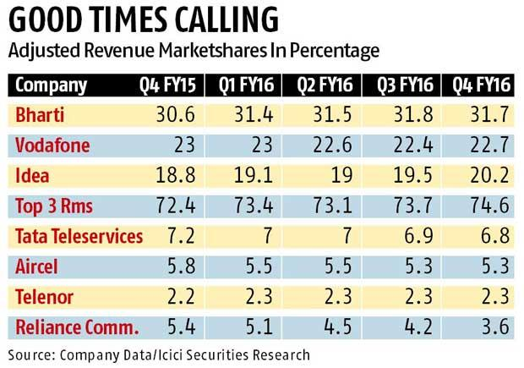

Idea, on the other hand, fared well across categories and its RMS rose 140 basis points y-o-y and 67 basis points sequentially to 20.2 per cent. Vodafone’s RMS during the quarter stood at 22. 7 per cent, down 30 basis points sequentially but up 30 basis points compared to corresponding period last year. In a note, ICICI Securities says: “Vodafone’s adjusted gross revenue market share improvement could be partly attributed to 2G ICR agreement with RComm. RComm lost 900 MHz spectrum in five circles West Bengal, Bihar, Odisha, Assam and North-East, and these are circles where Vodafone gained incremental AGR market share.

**TOP 5 IDEA CELLULAR COMPETITORS**

1. **Bharti Airtel Limited-** Bharti Airtel Limited, commonly known as Airtel, is an Indian multinational telecommunications services company headquartered in New Delhi, India. It operates in 20 countries across South Asia, Africa, and the Channel Islands. Airtel has a GSM network in all countries in which it operates, providing 2G, 3G and 4G services depending upon the country of operation. Airtel is the world's third largest mobile telecommunications company by subscribers, with over 275 million subscribers across 20 countries as of July 2013.[6] It is the largest cellular service provider in India, with 192.22 million subscribers as of August 2013.[7] Airtel is the Second largest Asia-Pacific mobile operator by subscriber base, behind China Mobile. Airtel is the largest provider of mobile telephony and second largest provider of fixed telephony in India, and is also a provider of broadband and subscription television services. It offers its telecom services under the "airtel" brand, and is headed by Sunil Bharti Mittal. Bharti Airtel is the first Indian telecom service provider to achieve Cisco Gold Certification.[8] It also acts as a carrier for national and international long distance communication services. The company has a submarine cable landing station at Chennai, which connects the submarine cable connecting Chennai and Singapore.

**Public relation , mobile , telephony, telecommunications and wirelss**

1. **Vodafone -** Vodafone is one of the world's largest telecommunications companies and provides a range of services including voice, messaging, data and fixed communications. Vodafone has mobile operations in 26 countries, partners with mobile networks in 56 more, and fixed broadband operations in 17 markets. As of 30 June 2016, Vodafone had 465 million mobile customers and 13.7 million fixed broadband customers.

**Internet , Telecommunication , Mobile Wireless.**

1. **Reliance Communication -** About Reliance Communications: Reliance Communications Limited, founded by the late Shri Dhirubhai H Ambani (1932-2002) is the flagship company of the Reliance Anil Dhirubhai Ambani Group. The Reliance Anil Dhirubhai Ambani Group currently has net worth in excess of Rs. 40,000 crore, cash flows of Rs. 9,000 crore, net profit of Rs. 5,000 crore and zero net debt. Rated among "Asia's Top 5 Most Valuable Telecom Companies", Reliance Communications is India's foremost and truly integrated telecommunications service provider. The company, with a customer base of around 48 million including over 1.5 million individual overseas retail customers, ranks among the Top 10 Asian Telecom companies by number of customers. Reliance Communications' corporate clientele includes 1850 Indian and multinational corporations, and over 200 global carriers. Reliance Communications has established a pan-India, next generation, integrated (wireless and wireline), convergent (voice, data and video) digital network that is capable of supporting best-of-class services spanning the entire info comm value chain, covering over 15,000 towns and 400,000 villages. Reliance Communications owns and operates the world's largest next generation IP enabled connectivity infrastructure, comprising over 175,000 kilometers of fibre optic cable systems in India, USA, Europe, Middle East and the Asia Pacific region.

**Infrastructure , service industry, Telecommunications , national level telecom operator.**

1. **Tata Docomo** – Tata Docomo offers Prepaid & Postpaid Plans, 3G Internet Packs & Broadband Services in India. One of the fastest growing tele services & internet services brand in India.

[**voice solutions sip trunk, pri, toll free, centrex**](https://datafox.com/keywords/voice%20solutions%20sip%20trunk,%20pri,%20toll%20free,%20centrex)**,**[**business solutions location based solutions, mobile applications**](https://datafox.com/keywords/business%20solutions%20location%20based%20solutions,%20mobile%20applications)**,**[**data and internet internet leased line, mpls vpn, content delivery**](https://datafox.com/keywords/data%20and%20internet%20internet%20leased%20line,%20mpls%20vpn,%20content%20delivery)**,**[**managed services hosting, security, storage, threat management**](https://datafox.com/keywords/managed%20services%20hosting,%20security,%20storage,%20threat%20management)**.**

1. **BSNL -**  Bharat Sanchar Nigam Limited abbreviated BSNL is an Indian state-owned telecommunications company headquartered in New Delhi. It was incorporated on 15 September 2000 and assumed the business of providing telecom services and network management from the erstwhile Central Government Departments of Telecom Services (DTS) and Telecom Operations (DTO) as of 1 October 2000 on a going-concern basis. It is the largest provider of fixed telephony and broadband services with more than 60% market share, and is the Fifth largest mobile telephony provider in India. However, in recent years, the company's revenues and market share have plummeted resulting in heavy losses as a result of intense competition in the Indian telecommunications sector. BSNL is India's oldest communication service provider and had a customer base of 93.29 million as of June 2015.It has footprints throughout India, except for Mumbai and New Delhi, where telecommunications are managed by Mahanagar Telephone Nigam MTNL.

[**Telecommunications**](https://datafox.com/keywords/telecommunications)**,**[**bsnl bharat Sanchar nigam limited**](https://datafox.com/keywords/bsnl%20bharat%20sanchar%20nigam%20limited)**,** [**telephony and wireless**](https://datafox.com/keywords/telephony%20and%20wireless)

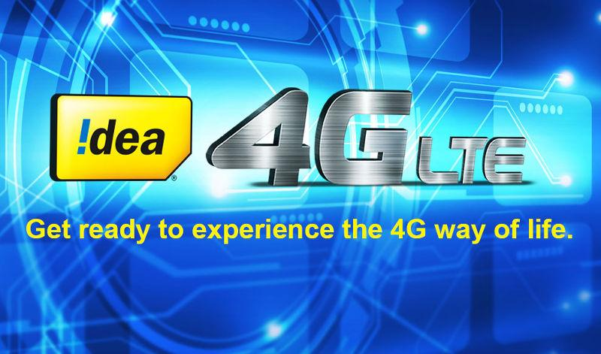

**MNP -** Idea MNP or mobile number portability, allows you to switch The mobile phone operator from Idea to another mobile phone provider and keep The existing mobile phone number**.**.. Yes, you can keep The existing Idea mobile phone number. This also applies if you are crossing states across the country moving Telecom Circles. You can switch The mobile phone operator or stay with the same operator in another state. This will prevent you from incurring roaming charges. The process is termed MNP or mobile number portability. It's quick and very easy to do - follow the instructions above for full details on how to transfer port The Idea mobile phone number to a new mobile phone network provider.

Idea MNP mobile number portability will incur a charge Rs 19 unless The new mobile phone provider pays this fee for you - ask them.

Idea MNP became available in India from 01 January 2011, however, the national rollout of Idea MNP across all States and Telecom Circles occurred on 3rd July 2015.

**MY IDEA APPS**

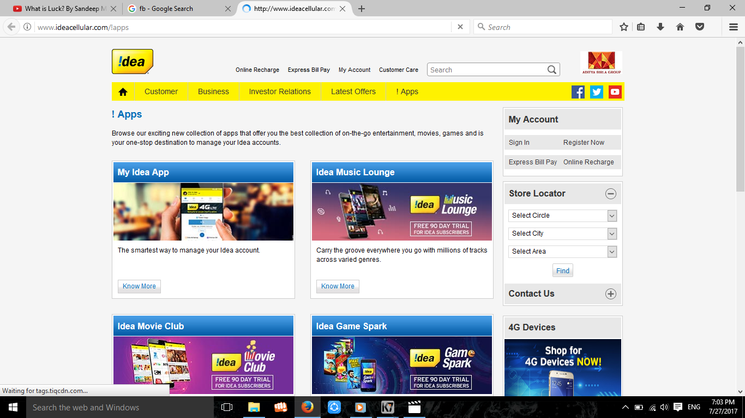

**Balance sheet**

(Rs crore)

|  | **Mar ' 17** | **Mar ' 16** | **Mar ' 15** | **Mar ' 14** | **Mar ' 13** |
| --- | --- | --- | --- | --- | --- |
| Sources of funds | | | | | |
| Owner's fund | | | | | |
| Equity share capital | 3,605.33 | 3,600.51 | 3,597.84 | 3,319.63 | 3,314.32 |
| Share application money | - | - | - | - | - |
| Preference share capital | - | - | - | - | - |
| Reserves & surplus | 20,118.43 | 20,695.40 | 18,292.30 | 12,264.72 | 10,705.58 |
| Loan funds | | | | | |
| Secured loans | 7,858.93 | 4,099.59 | 6,206.67 | 7,891.32 | 7,932.68 |
| Unsecured loans | 43,812.55 | 33,704.30 | 9,951.21 | 9,861.92 | 3,346.75 |
| Total | 75,395.24 | 62,099.80 | 38,048.02 | 33,337.59 | 25,299.34 |
| Uses of funds | | | | | |
| Fixed assets | | | | | |
| Gross block | 85,501.14 | 87,988.56 | 51,212.18 | 41,352.37 | 37,902.31 |
| Less : revaluation reserve | - | - | - | - | - |
| Less : accumulated depreciation | 9,376.15 | 23,072.24 | 19,098.27 | 15,328.25 | 11,963.76 |
| Net block | 76,124.98 | 64,916.32 | 32,113.91 | 26,024.12 | 25,938.55 |
| Capital work-in-progress | 7,529.20 | 6,038.83 | 5,079.45 | 11,380.12 | 843.43 |
| Investments | 6,251.31 | 2,498.95 | 12,814.11 | 1,641.21 | 2,567.31 |
| Net current assets | | | | | |
| Current assets, loans & advances | 5,856.93 | 6,353.79 | 7,668.38 | 4,942.91 | 5,077.37 |
| Less : current liabilities & provisions | 20,367.18 | 17,708.08 | 19,627.82 | 10,650.77 | 9,127.31 |
| Total net current assets | -14,510.25 | -11,354.29 | -11,959.44 | -5,707.86 | -4,049.94 |
| Miscellaneous expenses not written | - | - | - | - | - |
| Total | 75,395.24 | 62,099.80 | 38,048.02 | 33,337.59 | 25,299.34 |
| Notes: | | | | | |
| Book value of unquoted investments | 6,251.31 | 2,498.95 | 12,814.11 | 1,641.21 | 2,567.31 |
| Market value of quoted investments | - | - | - | - | - |
| Contingent liabilities | 29,513.00 | 25,478.46 | 54,236.32 | 14,957.68 | 13,528.90 |
| Number of equity sharesoutstanding (Lacs) | 36053.28 | 36005.09 | 35978.44 | 33196.32 | 33143.22 |

http://imads.rediff.com/0/default/empty.gif

**Reliance Jio Effect: Idea to Launch ‘Digital Idea’ Movies, Music, TV, Gaming AppsAditya Birla Group3G/4G Postpaid & Prepaid Mobile Phone & Data Card Services - Idea Cellular**

* Before an online recharge, kindly visit the Online tariff section for a detailed description.
* Dear Subscribers, kindly do not respond to missed calls from unknown international numbers or calls about winning prizes or lottery.
* Deactivation of Data Service: You can deactivate data services from your data default plan by sending an SMS “STOP” to 1925, or dial 1925 and then press 2.
* Reactivation of Data Service: You can reactivate data services if you have deactivated the data services earlier, by sending an SMS “START” to 1925, or dial 1925 and then press 1.
* Deactivation of Value Added Service (VAS): To cancel a VAS subscription, SMS "STOP" to 155223 (toll free) and select the service you wish to deactivate OR Dial 155223 (toll free) and select the service you wish to deactivate.
* Idea Money is an initiative from Idea Mobile Commerce Services Ltd. (IMCSL).
* Inclusive of applicable taxes. GST : 18% on applicable values.

**Highlights**

* Idea Cellular will unveil the Digital Idea apps suite on January 30
* The first apps to be launched will focus on movies, music, and games
* More Idea apps will be launched in 2017

Idea Cellular has sent out media invites for a Monday, January 30 event where it will launch its ‘Digital Idea’ apps suite to take on [Reliance Jio’s](http://gadgets.ndtv.com/tags/reliance-jio) range of apps that come preloaded with [Lyf](http://gadgets.ndtv.com/mobiles/lyf-phones) phones. In the invite, [Idea](http://gadgets.ndtv.com/tags/idea) also says that the launch of the Digital Idea apps is part of its transition to becoming a pan-India mobile broadband operator and full service digital solutions company.

With the ‘Digital Idea’ suite, Idea will launch movies, TV, music, and gaming apps, among others, it said. These apps are aimed at the “on-the-move online generation,” Idea said; Reliance Jio apps already has apps focused on music, movies, and TV. A host of preloaded media streaming and gaming apps entail higher data consumption by the user, meaning more revenue from [mobile data](http://gadgets.ndtv.com/tags/mobile-data) services. In its [quarterly report](https://www.ideacellular.com/wps/wcm/connect/4750974f-751b-463b-a87b-16820399c41d/Idea+-+Investor+Presentation+Q2FY17.pdf?MOD=AJPERES&CACHEID=4750974f-751b-463b-a87b-16820399c41d) released in September 2016, Idea had announced plans to launch these content apps, which were called Idea Games, Idea Videos, and Idea Music. Idea Chat is another app that the operator planned to launch alongside the content apps in the January-March quarter.

The [Reliance Jio apps](http://gadgets.ndtv.com/apps/features/reliance-jio-apps-how-they-stack-up-3-months-later-1639354) that Idea’s new apps will compete with include JioCinema, JioTV, and JioMusic. The Mukesh Ambani-backed telecom operator does not have a gaming app in the market yet. Other similar Jio apps available to download are JioMags, JioXpressNews, and JioNewspaper. At present, Idea Cellular offers music and movies to its consumers as discounted subscriptions for Hungama Digital and EROS content. However, it does not have any original content yet. [Airtel](http://gadgets.ndtv.com/tags/airtel) already has its [Wynk Music](http://gadgets.ndtv.com/tags/wynk-music) and [Wynk Movies](http://gadgets.ndtv.com/tags/wynk-movies) apps in the market, while [Vodafone](http://gadgets.ndtv.com/tags/vodafone) has the Vodafone Play app in the same space. In the next fiscal year, Idea will launch more apps, namely Idea TV, Idea News & Magazines, and Idea Storage, making it better positioned to take on Reliance Jio's suite of apps. It will also launch the [Aditya Birla Idea Payment Bank](http://gadgets.ndtv.com/internet/news/idea-aditya-birla-nuvo-apply-for-payments-bank-licence-656824), in which Idea Cellular has a 49 percent stake, in FY17-18, the report said.

Apart from the launch of Digital Idea apps, the move to becoming a mobile broadband operator is also a significant shift for Idea. However, this had also been foreshadowed by the company in its September 2016 report, which came out just before Reliance Jio launched its services. While the mobile voice segment has high competition (6-9 operators), the competition is less in the

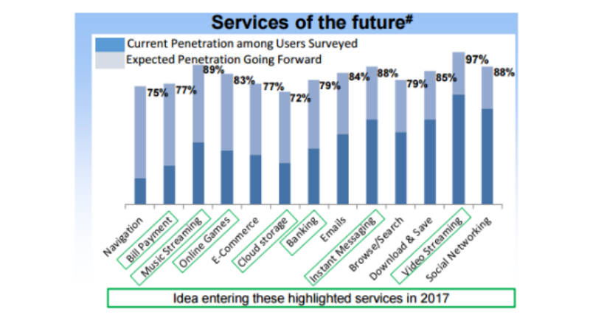

**Idea Takes On The Digital Space As It Expands Nationally**

Latest Marketing Innovation Dada to connect with audience from the East  
 After an excellent consumer response to Idea Mumbai Indians campaign, comes IDEAs latest offering in digital space in the form of a virtual character called Dada. *Dadas* apparent resemblance with a person hailing from East India is a deliberate attempt to create visibility for IDEA amongst the youth community on the internet, as the company rapidly expands its operations in the eastern parts of the country. *Dadas* apparent speech impediment, which either comes naturally or is caused by the ever-present beetle nut leaf in his mouth, instantly connects with audience from the East The viral film revolves around theno-win situation *Dada* is faced with in Orissa, and the subsequent transformation that he undergoes - thanks to an idea that he gets! IDEA has created a portal www.dadakiduvidha.com which will carry interesting stories about Dada.

 In the first film, Dada plays a Tour Guide who is not well aware abouthistory, current affairs, and general informationabout the city of Puri in Orissa, but makes up for it with his affable nature. Launching the first viral in the digital space, Mr. Pradeep Shrivastava, Chief Marketing Officer, IDEA Cellular said, "We are hopeful that the beloved character of *Dada* will engage a large number of people in the digital space, thus helping us gain mindshare and establish connect with our TG.

## Annual Report 2016-17

**Company Overview**

The Company is the third largest mobile telecommunications operator in the country, with Pan India operations offering Voice, Broadband Data, Value Added Services (VAS), Digital Content and Mobile Banking Services. The Revenue Market Share (RMS) for The Company stands at 18.7% for the quarter ended December 2016. As of February, 2017, the subscriber base of The company stands at 196.1 Min (on VLR), with subscriber market share of 19.4%.

The GSM-based 2G services of The Company are available in all 22 service areas of India, covering approximately 1 billion Indians, in nearly 400,000 towns and villages. In October 2016 spectrum auction, The Company has acquired 349.2 MHz of spectrum and completed its Pan India broadband spectrum footprint. The Company now owns 3G spectrum in 15 Service Areas and 4G spectrum in 20 Service Areas out of 22 Service Areas.

During the year The Company has launched 3G services in 2 additional service areas of Bihar and Rajasthan on its own spectrum, taking the total count to 15 from earlier 13. However, the 3G services of The Company are available in 21 Service Areas (excluding Odisha) including through intra-circle roaming arrangements with other mobile telecommunications service providers. On 4G front, The Company has rolled out 4G services in 9 new service areas during the year. The 4G launch in Mumbai service area is slated by end of May, 2017, post which the 4G services of The Company will be available in 20 Service Areas (Except Kolkata and Delhi). The Company also holds licenses to offer NLD, ILD and ISP services and registration for IP-1 services. While the NLD and ISP services mainly cater to the captive needs of the Company, the ILD and IP-1 services cater to external customers as well.

Financial Results The financial statements of the Company have been prepared in accordance with the Indian Accounting Standards (Ind AS) notified under section 133 of the Companies Act, 2013 read with Companies (Accounts) Rules, 2014. The financial statements for the Financial Year ended March 31, 2017 are the Company’s first Ind AS compliant annual financial statements with comparative figures for the year ended March 31, 2016 also under Ind AS. The date of transition is April 1, 2015. The disclosure and effects of first time adoption of Ind AS are detailed in Note 5 of the standalone financial statements and Note 6 of the consolidated financial statements for detailed disclosure and effects on the first time adoption of Ind AS.

**CHAPTER 3**

## 3.1 STRENGTH & WEAKNESS

| **Strength -** | * Flexible plans * Good Advertising. * High Brand Visiblity. * Celebrity Brand ambassadors. |
| --- | --- |
| **Weakness -** | * Price competition in MTNL and BSNL. * Untapped Rural market. |
| **Opportunities -** | * Fast expanding cellular market * Latest and low cost technology. * Untapped rural market |
| **Threat -** | * New entrant's low price offering. * Saturation point in Basic telephony service. * Mobile Number Portability. |

# 

# CHAPTER 4

# 4.1 INTRODUCTION OF THE CONCEPTIdea-4G.jpg

Digital apps are software applications that are used to expand business communication and content. Digital apps are use for specific purpose and are designed to present a unique look and style. Digital apps are designed for mobiles, tablet publication apps and it tends to incorporate elements such as : high quality videos, photos, audio.

Digital apps are also used to develop self-driven and confident individuals so that people can get aware about new technology and enhance their knowledge so that in future people adapts things easily.

Some of the apps are:

Idea Music Lounge, Idea Movie Club and Idea Game Spark offer a complete suite of

digital entertainment services.

* **Idea Music** **Lounge** offers a rich library of nearly 3 million Indian and international music tracks initially, which will be expanding to nearly 20 million tracks soon and is available on Google Play store. Idea Music Lounge hosts diverse content not only across 13 Indian languages, including Bollywood, South Indian Cinema etc, but also across International artists, albums and tracks from several major Music labels. As of March 31, 2017 over 550,000 customers are using Idea Music app.
* **Idea Movie Club** caters to the ever-growing video content needs of consumers, offering thousands of blockbuster movies, Live TV, 7 days catch-up TV, along with a series of original content and Short Videos across all genres and several languages. The rich content of videos and movies from Bollywood, South Indian & Regional Cinema will appeal to people across all age groups, including kids, for whom there are a host of animation and learning videos. Live and Catch up TV including premium channels, is offered in collaboration with Ditto TV. The app is available on Google Play Store and iOS store. As of March 31, 2017 nearly 275,000 customers are using Idea Movies Club app.
* **Idea Game Spark** is the ultimate gaming destination with a collection of over 1,600 games across all genres. Targeted at the gaming aficionado and the casual gamer, the games can be played both in the online and offline mode. As of March 31, 2017 over 500,000 customers are using Idea Game Spark. These apps are competitively priced. With the launch of these apps the company has taken one more step towards transformation from a pure play mobile operator to an integrated digital services and solutions provider.

# 4.2  7 NEW SERVICE AREAS – OPPORTUNITY

* Launched services during FY10; combined RMS of 4.0%1 in Q3FY14.
* Won 3G Spectrum 2100 MHz in J&K May 2010.
* Acquired 5 MHz spectrum in 1800 MHz frequency auction in Nov’12 6.25 MHz in West Bengal) in these service areas (post cancellation of license by Supreme Court
* Won LTE 4G spectrum 1800 MHz for Northeast in Feb’14 auction.
* Leverage synergies of pan India operations i.e. roaming, NLD, Ad spend, common network elements.
* Provides growth opportunity as number of licenses reduce

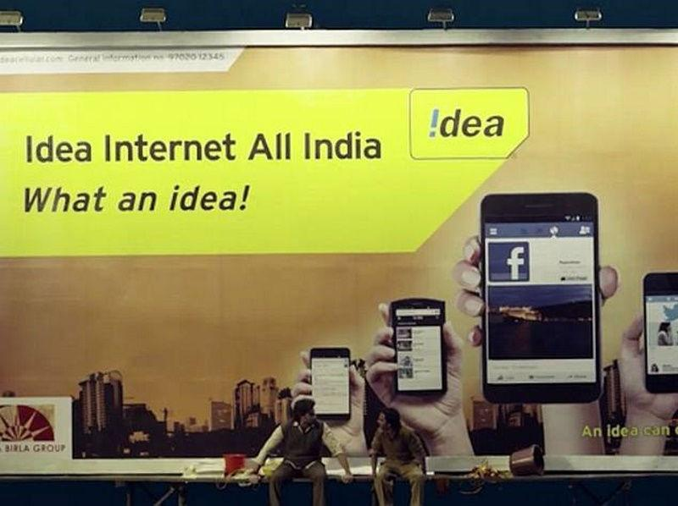

**Customers Statistics & their preference in terms of Idea Digital App.**

| 8225846193 | My idea , movies music games |
| --- | --- |
| 8889744954 | My idea , movies music games |
| 9424318006 | My idea , movies music games |
| 8878450500 | My idea , movies music games |

**Frequency of port in Idea**

|  | | | | |  |
| --- | --- | --- | --- | --- | --- |
| **24/07/17** | **Name** | **Mob No** | **Sim Port Done** |
|  | **Brijendra singh**  **Sweety Sharma**  **Shweta Gupta**  **Shivam Rathore**  **Manish kirar**  **Mukesh Sharma**  **Bhanupratap singh** | **8461841883**  **8120698020**  **7089018180**  **9074409075**  **9691913201**  **9009675329**  **7697584954** | **Airtel To Idea**  **Vodafone To Idea**  **Vodafone To Idea**  **Tata Docomo To Idea**  **Jio to Idea**  **Airtel To Idea**  **Airtel To Idea** |
| **25/07/17** | **Jai narayan patel**  **Rahul bansal**  **Anant kumar**  **Kevan patel**  **Sarla Sharma** | **9165913205**  **9516171449**  **9826223969**  **8349638431**  **9926558840** | **Airtel To Idea**  **Vodafone To Idea**  **Tata Docomo To Idea**  **Airtel To Idea**  **Tata Docomo To Idea** |
| **26/07/17** | **Anjana kumara**  **Kailash kumar**  **Abhishek** | **8120067560**  **7509050356**  **9754863411** | **Vodafone To Idea**  **Tata Docomo To Idea**  **Airtel To Idea** |
| **27/07/17** | **Krishnan kumar**  **Divya singh**  **Rajesh kumar**  **Vinay kushwah**  **Pankaj Bamoria**  **Sanjay singh**  **Mukesh**  **Brijmohan singh** | **9174919678**  **7693882443**  **9329816319**  **7049758217**  **9009608650**  **9644147078**  **9826299188**  **7354138641** | **Vodafone To Idea**  **Airtel To Idea**  **Airtel To Idea**  **Tata Docomo To Idea**  **Tata Docomo To Idea**  **Airtel To Idea**  **Jio to Idea**  **Airtel To Idea** |
| **29/07/17** | **Ashok tiwari**  **Neelam Bhadoria**  **Sheetal jadon**  **Gaurav kumar**  **Arun mishra** | **7693882443**  **9329816319**  **7049758217**  **9009608650**  **9644147078** | **Airtel to idea**  **Vodfone to idea**  **Airtel to idea**  **Tatadocomo to idea**  **Tata docomo to idea** |
| **1/08/17** | **Kapil Sharma**  **Richa pathak**  **Nitin verma** | **9644147078**  **9617969281**  **9826233474** | **Airtel to idea**  **Tatadocomo to idea**  **Tata docomo to idea** |
| **2/08/17** | **Mahesh**  **Suresh singh**  **Amit shrives**  **Anuj kumar** | **89180357447**  **8964961424**  **8120620840**  **8962572459** | **Airtel to idea**  **Airtel to idea**  **Tata docomo to idea**  **Jio to idea** |
| **4/08/17** | **Ashok**  **Suresh kumar**  **Sheetal jain**  **vikram** | **9962572453**  **9938364314**  **9009903894**  **8889744954** | **Airtel to idea**  **Airtel to idea**  **Vodafone to idea**  **Airtel to idea** |
| **8/08/17** | **Gaurav kumar**  **Rajesh kumar**  **Mohan singh**  **Udit**  **Rinki bhadoria**  **Ajit kumar**  **Govinda verma**  **Sapna devi** | **7967802220**  **9669677857**  **9977387144**  **8435106790**  **8224045709**  **7773880050**  **7697584954**  **8349638431** | **Airtel to idea**  **Airtel to idea**  **Vodafone to idea**  **Airtel to idea**  **Airtel to idea**  **Airtel to idea**  **Vodafone to idea**  **Airtel to idea** |
| **19/08/17** | **Kamal singh**  **Ranjana Kushwah**  **Brijendra**  **Jagdish singh**  **Satish kumar**  **Savita jain**  **Hemant batham** | **8889260290**  **9988765584**  **9993845062**  **9993838040**  **9993039327**  **7415525918**  **8826025061** | **Airtel to idea**  **Airtel to idea**  **Vodafone to idea**  **Airtel to idea**  **Vodafone to idea**  **Airtel to idea**  **Airtel to idea** |
|  |
|  |  |

# People Are Delay that in Idea cellular It is Widely Adopted In Real World Mobile Apps. It Increase Revenue ,It have a Good Opportunity For Apps & Games music and My ideas ,When This Application Is Available To Users And Try To Track A Location He / She Must Be Turn On Network & Connection Then The Ads Will Shown On The Screen.After that this application The customers get the Net .

MNP Process Is Relatively New To India But Holds Lots Of Scope Consumers Can Easily Switch Between Operators Offering Different Plans While Retaining Their Old Number.Customers find that they are not satisfied with the SIM of that company because problems they face are the network problems. That’s why they Switch From one To another Company.

# 4.3 SUGESSTIONS AND IMPLICATIONS

### Suggestions

•  It should motivate the Retailer to increase sales revenue by giving gifts and rewards etc.

•  It should increase network quality in rural areas.

•  It should provide expertise regularly visit to Retailer to giving the knowledge of sales promotion, coming technology, offers and plans.

•  It should concentrate on advertisement like Road side hoardings and banners.

•  It should provide a service to retailer if by mistake any retailer recharges an amount to other number then on request of retailer it may come back by deduction of few percent.

### Implication

Idea is a strong brand in national market but now it is declining due to poor network, higher call rates and tariffs, poor service facility. So the company should focus on these areas and should emphasize the customer relation more and more through more campaigning and advertisement, more consumer complaints active cells to solve their issues as soon as possible. Then only the company can attain a good position in the market and can increase its sales and revenue.

# CHAPTER 5

## 5.1 CONCLUSION

Communication strategy of idea is very good because most of the people are well known to the service by idea .Being new to telecom industry, people are not confident to go for it. Also, competitors of idea are very much powerful in communicating as well as providing the service. And one thing which is focused is that the Brand Ambassador also plays an important role in catching the attention of the customer because most of the people reported that they liked Abhishek Bachchan.

It is always difficult to measure the effectiveness of service center this is to conclude that the research named as Scope of digital apps in gwalior will be useful for the organization this research has been done keeping the constraints and requirements of the Idea with the help of this research it in easy for Idea to know about the service center and customer satisfaction level.

## 5.2 REFERENCE

Jan, Sumaira. "Financial Statements Analysis of Idea Cellular & Reliance Telecommunications: A Comparative Study." *Imperial Journal of Interdisciplinary Research* 2.7 (2016).

<https://en.wikipedia.org/wiki/Idea_Cellular>.

[www.ideacellular.com](http://www.ideacellular.com)

<https://www.ideacellular.com/wps/wcm/connect/>.

[https://www.ideacellular.com/.../Idea+Cellular+Limited_Annual+Report_2015-16%](https://www.ideacellular.com/.../Idea+Cellular+Limited_Annual+Report_2015-16%25)

<https://www.slideshare.net/ishita53/idea-ppt>

<https://www.slideshare.net/chandan3129/final-project-on-idea>

<https://datafox.com/competitors/idea-cellular>

[www.theofficialboard.com/org-chart/idea-cellular](http://www.theofficialboard.com/org-chart/idea-cellular)

<https://www.ideacellular.com/my-idea-app>

WEEKLY WORK REPORT FORMAT

Name of the Student: Sonal sharma

Course and Section: MBA

Weekly report for (Duration of Week) :

| WEEK | FROM | TO | DESCRIPTION OF WORK |
| --- | --- | --- | --- |
| 1 | 25/07/17 | 31/07/17 | SIM Update , Retail Recharge , Tele Calling, 4G Sim sale.  EKYC. |
| 2 | 01/08/17 | 07/08/17 | Movies , Music , Games , My Idea Apps, SIM Update 3G To 4G , MNP. |
| 3 | 08/08/17 | 14/08/17 | Movies , Music , Games , My Idea Apps, SIM Update 3G To 4G , MNP. |
| 4 | 15/08/18 | 21/08/17 | EKYC Movies , Music , Games , My Idea Apps, SIM Update 3G To 4G , MNP. |
| 5 | 22/08/18 | 28/08/18 | MNP Movies , Music , Games , My Idea Apps, SIM Update 3G To 4G , |
|  | 29/08/17 | 04/09/17 | Movies , Music , Games , My Idea Apps, SIM Update 3G To 4G , MNP. |
| 6 | 05/08/17 | 07/09/17 | Movies , Music , Games , My Idea Apps, SIM Update 3G To 4G , MNP. |

Thanks and Regards,

Thes Sincerely

(Sonal Sharma)

ANNEXURE

DAILY WORK SHEET FOR SUMMER TRAINING REPORT

Name of the Student: Sonal Sharma

Course and Semester: MBA

Batch : 2017

Specialization: Human Resources and Marketing

Name of Summer Training Organization: Idea Cellular

| **Day** | **Date** | **Description of Work** |
| --- | --- | --- |
| **1** | **24/07/17** | Prepaid vs Postpaid Details where taught by idea cellular in office, Mobile Number Portablity how to do this work Sim portable exchange of sim like Idea to jio or airtel to jio, adhaar card linked verification. And postpaid SIM work. |
| **2** | **25/07/17** | Idea prepaid to Idea postpaid Connection doing in the Franchise. Downloading the application so that easily customer can do E billing and with this app they can recharge any packs plan recharge. |
| **3** | **26/07/17** | Done recharge of the sim net balance calling recharge , Filing the Postpaid plan forms, Tele calling for the E billing means they will get the bill in their email id , for doing the digital work removing the paperless bill.convincing them for that.Adhaar card link . |
| **4** | **27/07/17** | Working on the Idea crystal, for blocking the sim , when the customer came with the FIR for lost the mobile and Sim.tele calling to achieve the targets , of E-billing, adhaar card link verified, filling the form for the new sim card buying the customers. |
| **5** | **28/07/17** | Adhaar card linked , Sim portable from one to another sim. Selling the prepaid sim ,tele calling converting 3G SIM to 4G Idea apps download . |
| **6** | **29/07/17** | Filing the Postpaid plan forms, Tele calling for the E billing means they will get the bill in their email id , for doing the digital work removing the paperless bill.convincing them for that.Adhaar card link . |
| **7** | **30/07/17** | **Holiday** |
| **8** | **31/07/17** | Idea prepaid to Idea postpaid Connection doing in the Franchise. Downloading the application so that easily customer can do E billing and with this app they can recharge any packs plan recharge. Adhaar card linked , Sim portable from one to another sim. Selling the prepaid sim ,tele calling converting 3G SIM to 4G Idea apps download . |
| **9** | **1/08/17** | **Holiday** |
| **10** | **2/08/17** | Idea prepaid to Idea postpaid Connection doing in the Franchise. Downloading the application so that easily customer can do E billing and with this app they can recharge any packs plan recharge. Adhaar card link . |
| **11** | **3/08/17** | Working on the Idea crystal, for blocking the sim , when the customer came with the FIR for lost the mobile and Sim.tele calling to achieve the targets , of E-billing, adhaar card link verified, filling the form for the new sim card buying the customers |
| **12** | **4/08/17** | Adhaar card linked , Sim portable from one to another sim. Selling the prepaid sim ,tele calling converting 3G SIM to 4G Idea apps download . |
| **13** | **5/08/17** | Idea prepaid to Idea postpaid Connection doing in the Franchise. Downloading the application so that easily customer can do E billing and with this app they can recharge any packs plan recharge. Adhaar card linked , Sim portable from one to another sim. Selling the prepaid sim ,tele calling converting 3G SIM to 4G Idea apps download . |
| **14** | **6/08/17** | Idea prepaid to Idea postpaid Connection doing in the Franchise. Downloading the application so that easily customer can do E billing and with this app they can recharge any packs plan recharge. Adhaar card linked , Sim portable from one to another sim. Selling the prepaid sim ,tele calling converting 3G SIM to 4G Idea apps download . |
| **15** | **7/08/17** | **Holiday** |
| **16** | **8/08/17** | **Holiday** |
| **17** | **9/08/17** | Sim portable from one to another sim Tele calling for the E billing means they will get the bill in their email id , for doing the digital work removing the paperless bill.convincing them for that.Adhaar card link . |
| **18** | **10/08/17** | Adhaar card linked , Sim portable from one to another sim. Selling the prepaid sim ,tele calling converting 3G SIM to 4G Idea apps download . |
| **19** | **11/08/17** | Filing the Postpaid plan forms, Tele calling for the E billing means they will get the bill in their email id , for doing the digital work removing the paperless bill.convincing them for that.Adhaar card link . |
| **20** | **12/08/17** | Adhaar card linked , Sim portable from one to another sim. Selling the prepaid sim ,tele calling converting 3G SIM to 4G Idea apps download . Filing the Postpaid plan forms. |
| **21** | **13/08/17** | **Holiday** |
| **22** | **14/08/17** | Tele calling for the E billing means they will get the bill in their email id , for doing the digital work removing the paperless bill.convincing them for that.Adhaar card link . |
| **23** | **15/08/17** | Idea prepaid to Idea postpaid Connection doing in the Franchise. Downloading the application so that easily customer can do E billing and with this app they can recharge any packs plan recharge. Adhaar card linked , Sim portable from one to another sim. Selling the prepaid sim ,tele calling converting 3G SIM to 4G Idea apps download . |
| **24** | **16/08/17** | Adhaar card linked , Sim portable from one to another sim. Selling the prepaid sim ,tele calling converting 3G SIM to 4G Idea apps download . |
| **25** | **17/08/17** | Done recharge of the sim net balance calling recharge , Filing the Postpaid plan forms, Tele calling for the E billing means they will get the bill in their email id , for doing the digital work removing the paperless bill.convincing them for that.Adhaar card link |
| **26** | **18/08/17** | Filing the Postpaid plan forms, Tele calling for the E billing means they will get the bill in their email id , for doing the digital work removing the paperless bill.convincing them for that.Adhaar card link . |
| **27** | **19/08/17** | Tele calling for the E billing means they will get the bill in their email id , for doing the digital work removing the paperless bill.convincing them for that.Adhaar card link |
| **28** | **20/08/17** | **Holiday** |
| **29** | **21/08/17** | Done recharge of the sim net balance calling recharge , Filing the Postpaid plan forms, Tele calling for the E billing means they will get the bill in their email id , for doing the digital work removing the paperless bill.convincing them for that.Adhaar card link . |
| **30** | **22/08/17** | Tele calling for the E billing means they will get the bill in their email id , for doing the digital work removing the paperless bill.convincing them for that.Adhaar card link Tele calling for the E billing means they will get the bill in their email id , for doing the digital work removing the paperless bill.convincing them for that. |
| **31** | **23/08/17** | **Holiday** |
| **32** | **24/08/17** | Done recharge of the sim net balance calling recharge , Filing the Postpaid plan forms, Tele calling for the E billing means they will get the bill in their email id , for doing the digital work removing the paperless bill.convincing them for that.Adhaar card link . |
| **33** | **25/08/17** | Working on the Idea crystal, for blocking the sim , when the customer came with the FIR for lost the mobile and Sim.tele calling to achieve the targets , of E-billing, adhaar card link verified, filling the form for the new sim card buying the customers |
| **34** | **26/08/17** | Done recharge of the sim net balance calling recharge , Filing the Postpaid plan forms, Tele calling for the E billing means they will get the bill in their email id , for doing the digital work awareness in the franchise for paperless work digital idea bill.convincing .them for that.Adhaar card link . |
| **35** | **27/08/17** | **Holiday** |
| **36** | **28/08/17** | Done recharge of the sim net balance , portability.3G to 4G.upgradation. |
| **37** | **29/08/17** | Done recharge of the sim net balance calling recharge , Filing the Postpaid plan forms, Tele calling for the E billing means they will get the bill in their email id , for doing the digital work removing the paperless bill.convincing them for that.Adhaar card link . |
| **38** | **30/08/17** | when the customer came with the FIR for lost the mobile and Sim.tele calling to achieve the targets , of E-billing, adhaar card link verified, filling the form for the new sim card buying the customers |
| **39** | **31/08/17** | Working on the Idea crystal, for blocking the sim , when the customer came with the FIR for lost the mobile and Sim.tele calling to achieve the targets , of E-billing, adhaar card link verified, filling the form for the new sim card buying the customers |
| **40** | **1/09/17** | Done recharge of the sim net balance calling recharge , Filing the Postpaid plan forms, Tele calling for the E billing means they will get the bill in their email id , for doing the digital work awareness in the franchise for paperless work digital idea bill.convincing .them for that.Adhaar card link . |
| **41** | **2/09/17** | Blocking the sim , when the customer came with the FIR for lost the mobile and Sim.tele calling to achieve the targets , of E-billing, adhaar card link verified, filling the form for the new sim card buying the customers. |
| **42** | **3/09/17** | **holiday** |
| **43** | **4/09/17** | Tele calling for the E billing means they will get the bill in their email id , for doing the digital work removing the paperless bill.convincing them for that.Adhaar card link . |
| **44** | **5/09/17** | Working on the Idea crystal, for blocking the sim , when the customer came with the FIR for lost the mobile and Sim.tele calling to achieve the targets , of E-billing, adhaar card link verified, filling the form for the new sim card buying the customers |
| **45** | **6/09/17** | Done recharge of the sim net balance , portability.3G to 4G.upgradation. |

Name of the Faculty Guide: Prof.Chanda Gulati

Signature of Faculty Guide:

Remark:

Note: Student have to enclose this daily work report sheet with their summer training report at the time of submission along with the signature of their Faculty Guide. Student will not be able to submit his/ her file to the department without the signature of faculty guide.

**STUDENT EVALUATION FORM FOR FACULTY GUIDE**

Name of the Student: Sonal Sharma

Course: MBA

Specialization: HR

Section: D

Batch: 2016-18

Date and Day when student reported first time : 24/07/17

Kindly give feedback for the following points

1. Whether the student have reported before he/she proceeded for summer training .
   1. YES
   2. NO
2. Whether the Student get the approval for Topic of Summer Training
   1. YES
   2. NO
3. Kindly mark the performance of the student for following Parameters on a scale of 1 to 5

a. Regularity and Punctuality during training including reporting and submission of Weekly wok report

1 2 3 4 5

b. Openness for Learning and Acceptability of task allotted

1 2 3 4 5

c. Able to work in team

1 2 3 4 5

d. Behavior

1 2 3 4 5

e. Quality in work allotted

1 2 3 4 5

Overall Remark on Student performance

………………………………………………………………………………………………………………………………………………………………………………………………………………………………………………………………………………………………………………………

Date:

Place:

Name and Signature of Faculty Guide

Note: This evaluation sheet need to be enclosed with the report of the student at the time of submission.

`